**Service Learning** (Speaker: Ms. Pamela Truesdell, CEEMS Resource Person, UC; July 14th, 2015, 9:00 am–11:30 am)

Ms. Pamela Truesdell conducted this PD session. Ms. Truesdell biography has been presented on page I-71 for the PD session on CEEMS Poster Guidelines and Pointers, and so is not repeated here.

This session began with a brief overview of various resources available for teachers through National Academy’s Press. One book in particular, Successful K-12 STEM Education, was mentioned as a great resource for teachers. This book along with several others, are available for purchase as hard copies or downloaded from the National Academy’s Press website (<http://www.nap.edu/topic/282/education>) for free. A second resource, the Engineering is Elementary website (<http://www.eie.org/>), was introduced. This site was developed by the Museum of Boston and contains many meaningful service opportunities for students through a variety of curriculum products. These proposed activities have international connections to standards, require student reflection, and strategies to include students in planning process.

Next, the participants watched an excerpt of Peter BensonTed Talk, Fires to be Lit. The clip we watched can be found on YouTube (<https://www.youtube.com/watch?v=TqzUHcW58Us>). After viewing the TedTalk, the participants were introduced to a garden project Pamela Truesdell worked on with her students. This project engaged students in service learning and taught them agriculture and engineering topics. The proposed activity used the I-PARD model which is similar to the Engineering Design Process. The acronym I-PARD stands for: Investigate, Plan, Action, Reflection, and Design.

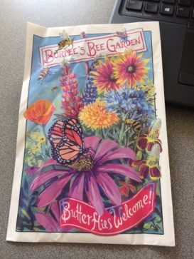

**Figure 1: Wildflower Packets Given to Participants**

Finally, the participants were encouraged given several examples of service learning projects including H2O For Life, Mason Bee House Project, Engineers Without Borders Curriculum Resources, and The Building Museum In Washington D.C. Grant opportunities and a list of suggested sites to search were also given via email and through the CEEMS Wiki. Some of these resources are displayed in **Figures 2 and 3** presented below. During the last hour of the session, participants were given time to begin exploring and planning service learning projects to use with their students and ask Ms. Pamela Truesdell questions. While working, participants were given cupcakes and a packet of wildflower seeds to plant at home or scatter alongside the road as a part of the “Guerrilla Gardening” Movement.

|  |  |
| --- | --- |
| **Figure 2: Snapshot of the Resource Obtained from the CEEMS Wiki** | **Figure 3: Snapshot of the Email from Ms. Truesdell regarding Grant Opportunities Related to Service Learning** |